HashMap – its collection in java where we store data in key-value pair.

1. Read data from Hashmap and store it into Excel.

# HashMap class implements MAP interface.

# The put() method inserts the elements in the map.

# Read the data from HashMap and write it into excel and parallely create rows and cell

# to read data from hashmap we have method – entrySet();

**for**( Map.Entry entry : data.entrySet())

in the above loop – we have taken 1st key and value pair in entry.set() method and store it in “entry” variable which is of type “Map.entry”

# **for**( Map.Entry entry : data.entrySet())

{

XSSFRow row = sheet.createRow(rowcount++);

row.createCell(0).setCellValue((String) entry.getKey());

row.createCell(1).setCellValue((String)entry.getValue());

}

OR 🡪

**for**( Entry<String, String> entry : data.entrySet())

{

XSSFRow row = sheet.createRow(rowcount++);

row.createCell(0).setCellValue((String)entry.getKey());

row.createCell(1).setCellValue((String)entry.getValue());

}

row.createcell(0) – will create cell at 0th index in 1st row and will set the cell data. Cell data will be 1st key.

row.createcell(1) – will create cell at 1st index in 1st row and will set the cell data. Cell data will be 1st value.

Then row count will be incremented and again above 2 lines will execute.

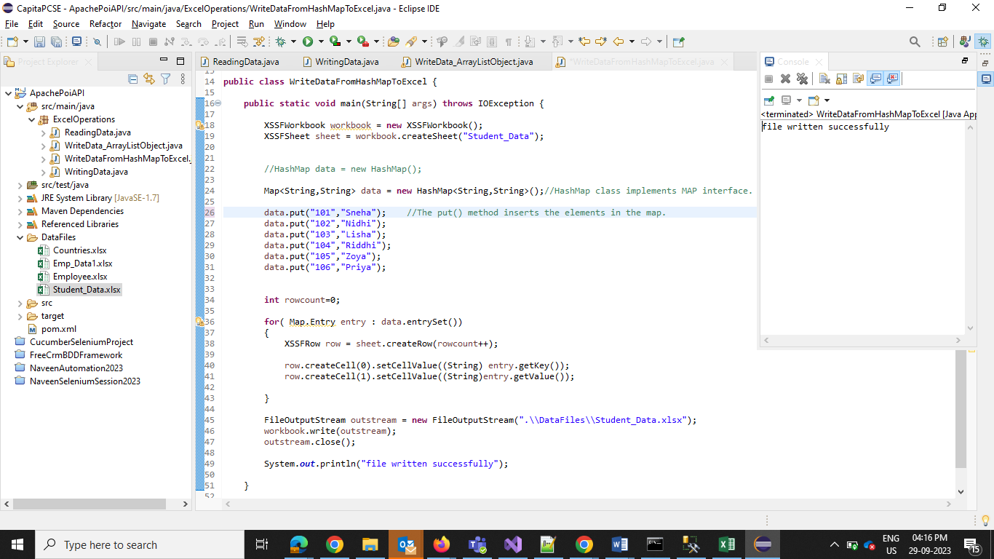

1. From reading data from excel and store into hashmap
2. Create excel with data – key value pair.
3. Open the excel file in reading mode using FileInputStream and pass the file path.
4. Create workbook and pass the InputStream
5. get sheet using workbook and mentioned the sheet name
6. From the sheet – count the no. of rows
7. Create 1 hashmap to store data
8. Create 1st for loop which will read data from excel and will put data into hashmap

//reading data from excel to HashMap

**For** (**int** r=0;r<rowNum;r++)

{

String key = sheet.getRow(r).getCell(0).getStringCellValue();

String value = sheet.getRow(r).getCell(1).getStringCellValue();

data.put(key, value);

}

sheet.getRow(r).getCell(0).getStringCellValue(); 🡪 get 0th row and then from the row get 0th col and get string value from that col and store as Key.

String value = sheet.getRow(r).getCell(1).getStringCellValue(); 🡪 get 0th row and then from the row get 1st col and get string value from that col and store as Key.

1. Another loop to read data from hash map

**for**(Map.Entry<String,String> entry : data.entrySet())

{

System.***out***.println(entry.getKey()+ " "+ entry.getValue());

}

